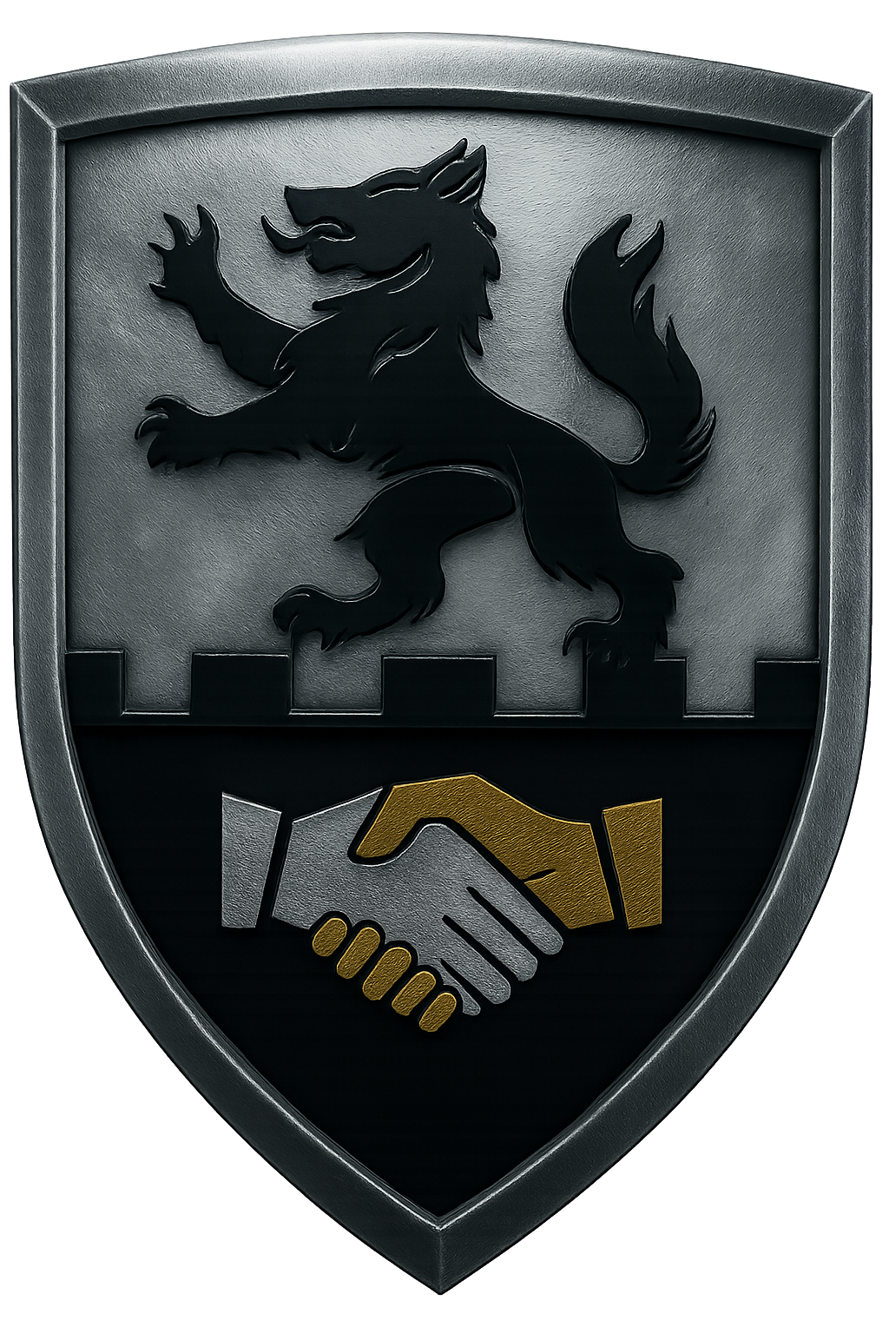
ROMEO KILO DEFENSE SYSTEMS LLC
Springfield, VA
romeokilodefense.us

Phantom Stack
The Control Plane for AI & Automation

The Problem
Organizations today buy 4–5 separate AI tools (Salesforce Einstein, Microsoft Copilot, UiPath, ServiceNow, etc.). Each tool is siloed, with its own license, integration, and compliance requirements. Leaders struggle with:
- Tool sprawl – too many overlapping systems.
- Compliance gaps – no single way to enforce rules.
- Audit fragmentation – each system logs separately.
- Vendor lock – trapped in one ecosystem.

The Solution
Phantom Stack (PS) is a control plane that orchestrates all AI and automation tools through a single backbone.
- Task Orchestration: Intake → Routing → Policy Enforcement → Unified Output.
- Compliance-first: DoD-grade policy packs and runtime enforcement.
- Vendor-agnostic: Works across existing bots, RPA tools, and internal automations.
- Unified audit: Immutable log across the entire digital workforce.

How It Works
1. A request enters Phantom Stack.
2. PS routes it to the right tool or bot (Einstein, UiPath, Copilot, in-house).
3. Policy engine ensures rules are enforced before/after execution.
4. Results are consolidated and returned as a single, auditable answer.

Deployment Models
- Air-gapped appliance (for DoD / high security).
- Self-hosted containers (GovCloud / on-prem).
- Managed SaaS (commercial enterprise).

Policy Packs
- Baseline: Derived from public regulations (CUI, PII, ITAR, Zero Trust).
- Domain: Co-developed with SMEs (e.g., Air Force SAM workflows).
- Local: Agency-authored rules.
- All packs are digitally signed and verified before loading.

Market Path
- Defense anchor: DISA validation → STIG-like runtime enforcement.
- Commercial: Critical infrastructure (energy, finance, healthcare) and enterprise compliance.

Pricing
Phantom Stack is priced comparably to a single enterprise AI license. The value is delivered through reduced tool sprawl, compliance assurance, and audit consolidation.

Differentiators
- Compliance-first architecture (DoD DNA).
- Vendor-agnostic orchestration.
- Runtime enforcement (not static checklists).
- Unified audit trail.
- Optional Phantom AI.R. module for persona-based digital workforce generation.

Tagline
“One secure control plane for all your AI and automation.”

